**Create and Deploy Files to GitHub via Git**

**Git link:** [https:](https://github.com/pravallikaadineni/mainprojects.git)

[//github.com/RBhuvaneswari01/mainprojects](https://github.com/RBhuvaneswari01/mainprojects)

**STEP 1:**Creating a repository in your GitHub account.

**STEP2:** Go to the homepage of GitHub.com and click on **New Repository** as shown below.

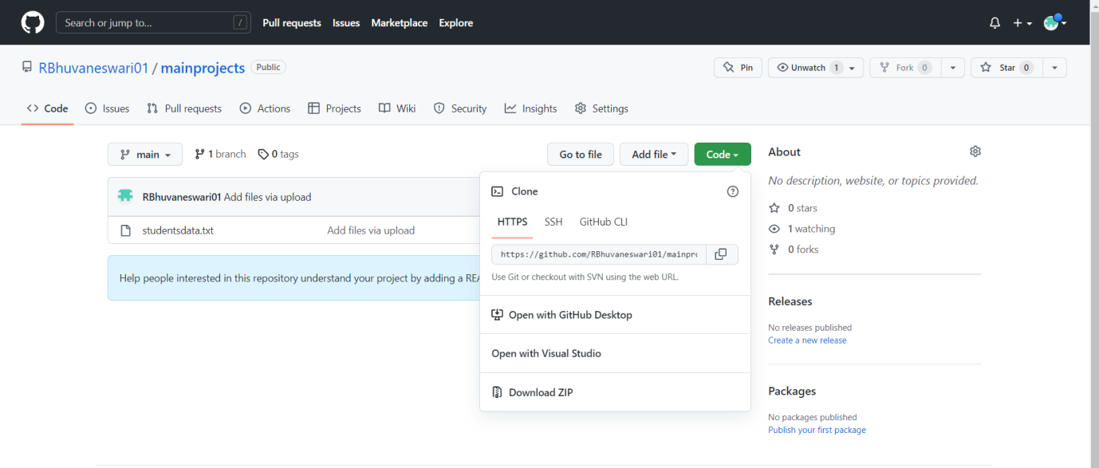

**STEP 3:**Choosing an angular applicationto push into git repository

**STEP 4**: Generating files and initializing the. git directory

* Pushing the code to your GitHub repositories

**STEP 5:** Open your command prompt and navigate to the folder where you have created your files.

**cd <folder path>**

**STEP 6:** Initialize your repository using the following command:

**git init**

**\***Add all the files to your git repository using the following command:

**git add.**

**\***Commit the changes using the following command:

**git commit -m “upload”**

*Push the files to the folder you created initially using the following command:

**git push origin main**

**STEP 7: COMMANDS**

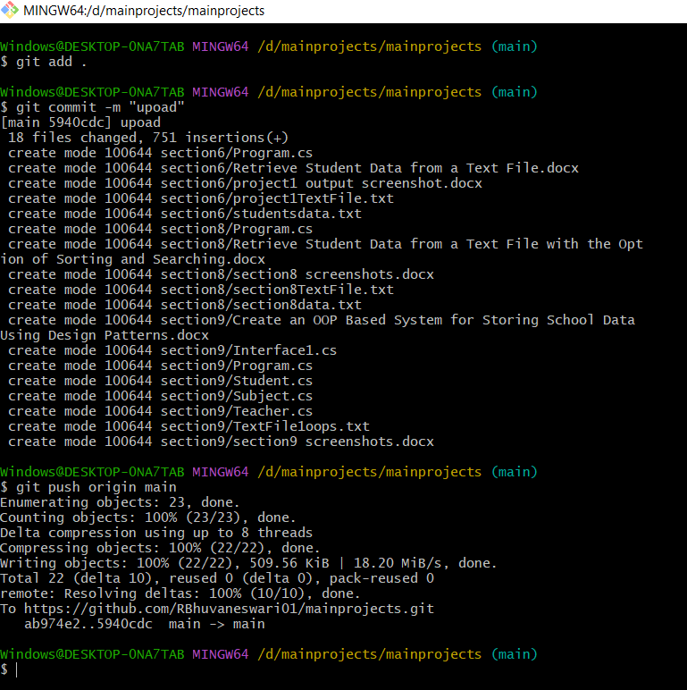

**STEP 8:** uploaded files on git hub as shown below

